CTM-I Use Case

Trade Entry

Version 0.1

Use Case Name | Trade Entry
Actor | Broker, Firm User, Market Ops, Ops, App Support
Pre-conditions /Assumptions | User has Browser and is aware of the http path to the application.  User has successfully logged into the CTM-I application.  User has the right role to see the menu options.
Post Conditions | None
Screenshot | 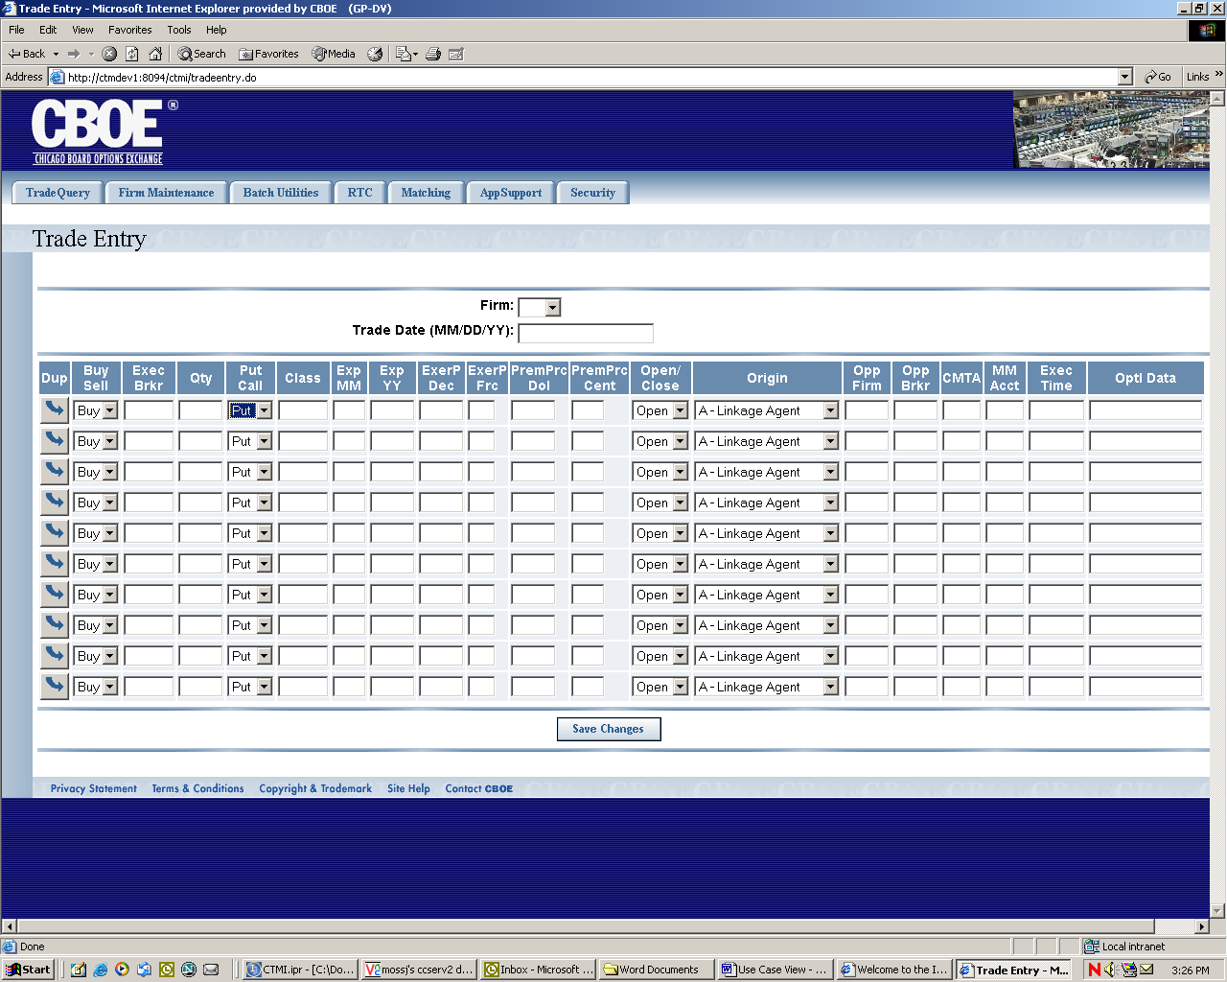
Flow of Events | - User selects “Trade Entry” from the menu.  - Trade Entry screen appears  - User can enter data in the following fields  - Firm  - The list of firms is limited by security  - Users with permissions to select any firm have all firms  - Users with limited firms can select firms they are authorized to see.  - Trade Date  - Trade Date will allow the user to select input date from pop up calendar.  - A pop-up Calendar will be available for easy selection of the date  - User will be able to add each of the following fields..  - Buy/Sell – Only valid values are “Buy” and “Sell”  - Executing Broker  - Quantity  - Put/Call – Only valid values are “Put” and “Call”  - Class  - Expiration Date  - Validation will be performed to ensure the date is in the format MMYY.  - Exercise Price Decimal  - Exercise Price Fraction  - Premium Price Dollar  - Premium Price Frac  - Open/Close – Only valid values are “” (blank), “Open” and “Close”  - Origin Indicator – Only valid Origin Indicators are allowed.  - Opposite Firm  - Opposite Broker  - CMTA  - MM Account  - Time of Execution  - Validation will be performed to ensure the data is in the format HHMMSS.  - Optional Data  - Duplication button will copy the previous record data into the line of the depressed button.  - 10 trades will be allowed at any one time.  - The ‘save’ button will send the data to CTM-R for validation and storage.  - Display number of records that were added on a blank Trade Entry screen
Alternative Path

